SAMBHRAM ACADEMY OF MANAGEMENT STUDIES


Amba Bhawani Temple Road M.S.Palya Bangalore-560097

DEPARTMENT OF COMPUTER SCIENCE
FOR THE ACADEMIC YEAR 2018-2019
Project Report
On
OLDAGE HOME
Was Successfully Carried out
By
RAJAT KUMAR: 16XWSB7033
Under the guidance
Of
Mrs. Sunitha
In partial fulfillment for the award of the Bachelor Degree in
BACHELOR OF COMPUTER APPLICATION (B.C.A.) in 6th Semester
Prescribed by the
BANGALORE UNIVERSITY
During the academic year of 2018-2019

Sambhram Academy of Management Studies
M.S.Palya Bangalore-560097

Department of Computer Application
Certificate

This is to certify that the project work entitled “OLDAGE HOME” is a bonafide work successfully carried out by RAJAT KUMAR (Reg.No.16XWSB7033) in partial fulfillment for the award of BACHELOR OF COMPUTER APPLICATION (BCA) in 6TH semester prescribed by the Bangalore University in the laboratory of this college for the academic year 2018-19.
This project work is carried out by him under the guidance and supervision of prof. Mrs. Sunitha.

Mrs. Sunitha Mrs.Nirmala
(Teacher Supervisor) (H.O.D.)

Examiner’s Signature:

2.

ACKNOWLEDGEMENT

I take great pleasure in expressing my gratitude to the Management “SAMBHRAM ACADEMY OF MANAGEMENT STUDIES” for giving me an opportunity to computerize my project “OLDAGE HOME” using HTML,CSS,JAVASCRIPT,PHP MYSQL.

I thank my college Principal Dr. K.C. Mishra for providing resources to complete my project successfully.

My sincere thanks to Prof. Mrs.Nirmala head of computer science department and my project guide Prof. Mrs.Sunitha for valuable guidance, support and co-operation. She has been my source of inspiration and Motivation.

I also thank to all those who guided me in successfully completing this project. I am thankful to the staffs of our department for providing us amazing facilities, constant encouragement, guidance and advice throughout my project.

Table of contents

Sl no. | Topic | Page no
1 | Introduction  - project introduction  - problem statement  - need | 6
2 | System analysis  2.1 Definition  2.2 Description of present system  2.3 Limitations of present system  2.4 Proposed System  2.5 Feasibility Study  2.5.1 Technical Feasibility  2.5.2 Economical Feasibility  2.5.3 Behavioral/ Operational  Feasibility  2.6 Project Planning and Scheduling  2.7 Software Engineering Paradigm  Applied | 7
3 | System specifications  3.1 Hardware Description  3.2 Software Description | 14
4 | Overview of language used  4.1 About HTML  4.2 About Java Script  4.3 About PHP  4.4 About MySQL  4.5 About Database | 15
5 | System design  5.1 Output Design  5.2 Input Design  5.3 Logical Design  5.4 Data Flow Diagram  5.5 Data Dictionary  5.6 ER – Diagram  5.7 Process Model | 27
6 | Coding | 34
7 | Testing  7.1 Black box Testing  7.2 White box Testing  7.3 Software Testing Strategies | 74
8 | Security | 76
9 | Screenshots | 77
10 | Future enhancement | 80
11 | Conclusion and Discussion | 81
12 | Bibliography | 82

1. INTRODUCTION

OLD AGE HOME
“Home for orphans and Elderly is an endeavour to create space where the two groups can live together, where one group can provide the other with what they lack. The aim of the project would be to establish a mutual relationship AMONGST the two groups. The elderly would act as parents while the children would be a source of happiness, someone in need, a responsibility. The elderly could play an important role in the children's lives, likewise the children could play an important role in lives of the elderly. The project also encourages people from outside to mingle with the people living in the home. Old age homes are meant for senior citizens who are unable to stay with their families or are destitute. States in India such as Delhi, Kerala, Maharashtra and West Bengal have developed good quality old age homes. These old age homes have special medical facilities for senior citizens such as mobile health care systems, ambulances, nurses and provision of well-balanced meals.
There are more than a thousand old age homes in India. Most of them offer free accommodation. Some homes work on a payment basis depending on the type and quality of services offered. Apart from food, shelter and medical amenities, old age homes also provide yoga classes to senior citizens. Old age homes also provide access to telephones and other forms of communication so that residents may keep in touch with their loved ones. Some old age homes have day care centres. These centres only take care of senior citizens during the day.
Purpose
For older people who have nowhere to go and no one to support them, old age homes provide a safe haven. These homes also create a family like atmosphere among the residents. Senior citizens experience a sense of security and friendship when they share their joys and sorrows with each other. Here is a list of a few old age homes in India.
Scope
- With growth of civilization and culture elderly persons are not getting care from their children.
- We need to develop such system to easy handle the elderly services

Goal
- The main goal of the application is to maintain the records of Oldage Home, booking and list all the facilities, This software is helpful to the Oldage Home to maintain the all activities record.

- SYSTEM ANALYSIS
2.1 DEFINATION
System Analysis is the detailed study of the various operations performed by the system and their relationships within and outside the system. Analysis is the process of breaking something into its parts so that the whole may be understood. System analysis is concerned with becoming aware of the problem, identifying the relevant and most decisional variables, analyzing and synthesizing the various factors and determining an optimal or at least a satisfactory solution. During this a problem is identified, alternate system solutions are studied and recommendations are made about committing the resources used to design the system
2.2 DESCRIPTION OF PRESENT SYSTEM
As most of the work is done manually or it is based on paper work such as finding old age homes, facilities, No of seat available, medical contacts and, doctors and other records related to old persons etc. These all process takes time. If we include all the work which will be based on online system, then it can reduce time and work. For example – If anyone have to query whether all old persons are present in, then he/she have to check/enquire and count manually. But under this system all the details will be produced by a single click on its user screen.

At present in Old age Home all records maintained manually. There are thousands of patients/olds persons joining each year. As the year goes then number of persons also get increases, for the staff to maintain all these records is very tedious and time consuming. Update Payment, Health Status, test result all these need to be done in time to achieve Oldage need to be recruit more peoples. To solve this problem this project is prepared which help the management to maintain the records accurately.

2.4 PROPOSED SYSTEM
Proposed System
In the proposed system all the parameter are considered to maintain neat and easier solutions. Person can get all the update sitting in home. He can find oldage home easily and can check facilities provided by them. They can see their wards health report online.

Modules of Oldage Home
- User Module
- Admin
- Doctor
- Patient:

The user can view their wards health status and payment details.
The user can know about Oldage Home info, management, goal & objective.
The user can easily view courses details as well as subject details which are college given you.
Admin:
Admin can perform add/update/delete and search following module:
- Available rooms
- the Health details
- Fooding details
- Can assign different work to different Staff
- login module & user type module
Doctor:
Doctor also gives a login to manage his/her profile.
They can view their appointment and upload status.

2.5 FEASIBILITY STUDY
A feasibility analysis usually involves a through assessment of the operational (need), financial and technical aspects of a proposal. Feasibility study is the test of the system proposal made to identify whether the user needs may be satisfied using the current software and hardware technologies, whether the system will be cost effective from a business point of view and whether it can be developed with the given budgetary constraints. A feasibility study should be relatively cheap and done at the earliest possible time. Depending on the study, the decision is made whether to go ahead with a more detailed analysis.

When a new project is proposed, it normally goes through feasibility assessment. Feasibility study is carried out to determine whether the proposed system is possible to develop with available resources and what should be the cost consideration. Facts considered in the feasibility analysis were.

- Technical Feasibility
- Economic Feasibility
- Behavioral Feasibility

2.5.1 Technical Feasibility

Technical Feasibility deals with the hardware as well as software requirements. Technology is not a constraint to type system development. We have to find out whether the necessary technology, the proposed equipments have the capacity to hold the data, which is used in the project, should be checked to carryout this technical feasibility.
The technical feasibility issues usually raised during the feasibility stage of investigation includes these
- This software is running in windows 2000 Operating System, which can be easily installed.
- The hardware required is Pentium based server.
- The system can be expanded.

2.5.2 Economical Feasibility
This feasibility study present tangible and intangible benefits from the prefect by comparing the development and operational cost. The technique of cost benefit analysis is often used as a basis for assessing economic feasibility. This system needs some more initial investment than the existing system, but it can be justifiable that it will improve quality of service.

Thus feasibility study should center along the following points:

- Improvement resulting over the existing method in terms of accuracy, timeliness.
- Cost comparison
- Estimate on the life expectancy of the hardware
- Overall objective
Our project is economically feasible. It does not require much cost to be involved in the overall process. The overall objectives are in easing out the requirement processes.

2.5.3 Behavioral/ Operational Feasibility

This analysis involves how it will work when it is installed and the assessment of political and managerial environment in which it is implemented. People are inherently resistant to change and computers have been known to facilitate change. The new proposed system is very much useful to the useful to the users and there for it will accept broad audience from around the world.

  - SOFTWARE ENGINEERING PARADIGM APPLIED
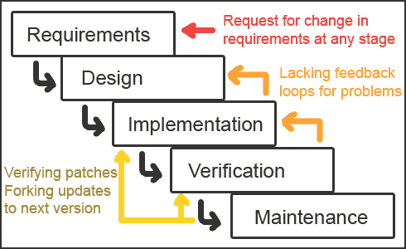

Waterfall Model

The waterfall model derivers its name due to the cascading effect from one phase to the other as is illustrated in above figure. In this model each phase well define starting and ending point, with identifiable deliveries to the next phase. Note that this model is sometime referred to as the linear sequential model or the software life cycle model. The water fall diagram is basically divided into following 5 models.

          - Requirement
          - Design
          - Implementation
          - Verification
          - Maintenance

  - Requirement:-

In the requirement phase the need to create the application is specified. What is the need of the system is defined. What information to be feeder to create the application will come under the requirement phase?

  - Design:

After the requirement phase the next phase is the Design phase where the application is designed according to the forms and other modules created. This phase is much important phase because it will structure the layout of your application.

  - Implementation:

Implementation is the process of having a system personnel phase check out and put new equipment into use, train users, install new application and construct any file of data need to use it.

  - Verification:

After the whole application is being the developed the main phase is the verification phase where the whole application tested and verified to check the whole application.

  - Maintenance:
After the successful verification of the application the main phase is the maintenance phase where the application needs to be maintained for its successful operation in future.

3. SYSTEM SPECIFICATIONS

3.1 HARDWARE DESCRIPTION

The selection of hardware is very important in the existence and proper working of any software. When selecting hardware, the size and requirements are also important.

Minimum Requirements:
Processor : Pentium II class, 450MHz
RAM : 128MB
Hard Disk Drive : 3GB
Video : 800X600, 256 colors
CD-ROM : Required

The proposed System is developed on:
Processor : INTEL Pentium 4
RAM : 512MB
Hard Disk Drive : 40GB
Key Board : Standard 101/102 or Digi Sync Family
Monitor : Display Panel (1024 X 764)
Display Adapter : Trident Super VGA
Network Adapter : SMC Ethernet Card Elite 16 Ultra
Mouse : Logitech Serial Mouse

3.2 SOFTWARE DESCRIPTION

Operating System : Windows XP and higher
Front- End : HTML, CSS, JAVA SCRIPT
Back- End : PHP, MYSQL

4. OVERVIEW OF THE LANGUAGE USED

4.1 About Html:-

UNDERSTANDING HTML

- HTML was originated by Tim Berners-Lee.
- HTML developed a few years ago as a subset of SGML (Standard Generalized Mark-up Language), which is a higher-level mark-up language that has long been a favorite of the Department of Defense.
- Any HTML document is also valid for SGML.
- HTML is a Hyper Text Markup Language that is used to develop web pages.
- HTML is not a programming language like C, C++ and Java etc.
- It is a cross platform markup language that is design to be flexible enough to display text and other elements like graphical on a variety of views.
- The HTML documents consists of special Tags that are embedded in an ASCII document.
- Web browser like Internet Explorer, Netscape Navigator etc, interprets these Tags.

Basic HTML
Tag | Description
<!DOCTYPE> | Defines the document type
<html> | Defines an HTML document
<head>
Defines information about the document
<title>
Defines a title for the document
<body> | Defines the document's body
<h1> to <h6> | Defines HTML headings
<p> | Defines a paragraph
<br> | Inserts a single line break
<hr> | Defines a thematic change in the content
<!--...--> | Defines a comment

Formatting
Tag | Description
<abbr> | Defines an abbreviation or an acronym
<address> | Defines contact information for the author/owner of a document/article
<b> | Defines bold text
<bdi> | Isolates a part of text that might be formatted in a different direction from other text outside it
<bdo> | Overrides the current text direction
<blockquote> | Defines a section that is quoted from another source
<cite> | Defines the title of a work
<code> | Defines a piece of computer code
<del> | Defines text that has been deleted from a document
<dfn> | Represents the defining instance of a term
<em> | Defines emphasized text
<i> | Defines a part of text in an alternate voice or mood
<ins> | Defines a text that has been inserted into a document
<kbd> | Defines keyboard input
<mark> | Defines marked/highlighted text
<meter> | Defines a scalar measurement within a known range (a gauge)
<pre> | Defines preformatted text
<progress> | Represents the progress of a task
<q> | Defines a short quotation
<rp> | Defines what to show in browsers that do not support ruby annotations
<rt> | Defines an explanation/pronunciation of characters (for East Asian typography)
<ruby> | Defines a ruby annotation (for East Asian typography)
<s> | Defines text that is no longer correct
<samp> | Defines sample output from a computer program
<small> | Defines smaller text
<strong> | Defines important text
<sub> | Defines subscripted text
<sup> | Defines superscripted text
<template> | Defines a template
<time> | Defines a date/time
<u> | Defines text that should be stylistically different from normal text
<var> | Defines a variable
<wbr> | Defines a possible line-break
Forms and Input
Tag | Description
<form> | Defines an HTML form for user input
<input> | Defines an input control
<textarea> | Defines a multiline input control (text area)
<button> | Defines a clickable button
<select> | Defines a drop-down list
<optgroup> | Defines a group of related options in a drop-down list
<option> | Defines an option in a drop-down list
<label> | Defines a label for an <input> element
<fieldset> | Groups related elements in a form
<legend> | Defines a caption for a <fieldset> element
<datalist> | Specifies a list of pre-defined options for input controls
<output> | Defines the result of a calculation

Frames
Tag | Description
<iframe> | Defines an inline frame

Images
Tag | Description
<img> | Defines an image
<map> | Defines a client-side image-map
<area> | Defines an area inside an image-map
<canvas> | Used to draw graphics, on the fly, via scripting (usually JavaScript)
<figcaption> | Defines a caption for a <figure> element
<figure> | Specifies self-contained content
<picture> | Defines a container for multiple image resources
<svg> | Defines a container for SVG graphics

Audio / Video
Tag | Description
<audio> | Defines sound content
<source> | Defines multiple media resources for media elements (<video>, <audio> and <picture>)
<track> | Defines text tracks for media elements (<video> and <audio>)
<video> | Defines a video or movie

Links
Tag | Description
<a> | Defines a hyperlink
<link> | Defines the relationship between a document and an external resource (most used to link to style sheets)
<nav> | Defines navigation links

Lists
Tag | Description
<ul> | Defines an unordered list
<ol> | Defines an ordered list
<li> | Defines a list item
<dl> | Defines a description list
<dt> | Defines a term/name in a description list
<dd> | Defines a description of a term/name in a description list
<menu> | Defines a list/menu of commands
<menuitem> | Defines a command/menu item that the user can invoke from a popup menu

Tables
Tag | Description
<table> | Defines a table
<caption> | Defines a table caption
<th> | Defines a header cell in a table
<tr> | Defines a row in a table
<td> | Defines a cell in a table
<thead> | Groups the header content in a table
<tbody> | Groups the body content in a table
<tfoot> | Groups the footer content in a table
<col> | Specifies column properties for each column within a <colgroup> element
<colgroup> | Specifies a group of one or more columns in a table for formatting

Styles and Semantics
Tag | Description
<style> | Defines style information for a document
<div> | Defines a section in a document
<span> | Defines a section in a document
<header> | Defines a header for a document or section
<footer> | Defines a footer for a document or section
<main> | Specifies the main content of a document
<section> | Defines a section in a document
<article> | Defines an article
<aside> | Defines content aside from the page content
<details> | Defines additional details that the user can view or hide
<dialog> | Defines a dialog box or window
<summary> | Defines a visible heading for a <details> element
<data> | Links the given content with a machine-readable translation

Meta Info
Tag | Description
<head> | Defines information about the document
<meta> | Defines metadata about an HTML document
<base> | Specifies the base URL/target for all relative URLs in a document

Programming
Tag | Description
<script> | Defines a client-side script
<noscript> | Defines an alternate content for users that do not support client-side scripts
<embed> | Defines a container for an external (non-HTML) application
<object> | Defines an embedded object
<param> | Defines a parameter for an object

4.2 About JavaScript:-

- What is JavaScript?

- JavaScript was designed to add interactivity to HTML pages
- JavaScript is a scripting language (a scripting language is a lightweight programming language)
- A JavaScript consists of lines of executable computer code
- A JavaScript is usually embedded directly into HTML pages
- JavaScript is an interpreted language (means that scripts execute without preliminary compilation)
- Everyone can use JavaScript without purchasing a license

- Are Java and JavaScript the Same?

- NO! Java and JavaScript are two completely different languages in both concept and design!
- Java (developed by Sun Microsystems) is a powerful and much more complex programming language - in the same category as C and C++.

- What can a JavaScript Do?

- JavaScript gives HTML designers a programming tool - HTML authors are normally not programmers, but JavaScript is a scripting language with a very simple syntax! Almost anyone can put small "snippets" of code into their HTML pages
JavaScript Syntax.

- Unlike HTML, JavaScript is case sensitive.
- Dot Syntax is used to combine terms.
e.g., document.write("Hello World")
- Certain characters and terms are reserved.
JavaScript is simple text (ASCII).

JavaScript Terminology

- JavaScript programming uses specialized terminology.
- Understanding JavaScript terms is fundamental to understanding the script.
- Objects, Properties, Methods, Events, Functions, Values, Variables, Expressions, Operators.
4.3 About Php:-

- Introduction to PHP:

- The full form of PHP is “Hypertext Preprocessor”. Its original name was “Personal Home Page”
- Rasmus Lerdorf software engineer, Apache team member is the creator and original driving force behind PHP. The first part of PHP was developed for his personal use in late 1994.
- By the middle of 1997, PHP was being used on approximately 50,000 sites worldwide.
- PHP is server-side scripting language, which can be embedded in HTML or used as a stand-alone.
- PHP doesn’t do anything about what a page looks and sounds like. In fact, most of what PHP does is invisible to the end user.
- Someone looking at a PHP page will not necessarily be able to tell that it was not written purely in HTML, because usually the result of PHP is HTML.
- PHP is an official module of Apache HTTP Server.
- PHP is fully cross-platform, meaning it runs native on several flavors of Unix, as well as on Windows and now on Mac OS X.

- Advantages of PHP

- Cost: PHP costs you nothing. It is open source software and doesn’t need to purchase it for development.
- Ease of Use: PHP is easy to learn, compared to the others. A lot of Ready-made PHP scripts are freely available in market so, you can use them in your project or get some help from them.
- HTML- Support: PHP is embedded within HTML; In other words, PHP pages are ordinary HTML pages that escape into PHP mode only when necessary. When a client requests this page, the web server preprocesses it. This means it goes through the page from top to bottom, looking for sections of PHP, which it will try to resolve.
- Cross-platform compatibility: MySQL run native on every popular flavor of Unix and windows. A huge percentage PHP and of the world’s HTTP servers run on one of these two classes of operating system.
- PHP is compatible with the three leading Web servers: Apache HTTP Server for Unix and Windows, Microsoft Internet Information Server, and Netscape Enterprise Server.

It also works with several lesser-known servers, including Alex Blits’ fhttpd, Microsoft’s Personal Web Server, AOL Server and Omnicentrix’s Omni server application server.

- Stability: The word stable means two different things in this context:
    - The server doesn’t need to be rebooted often
    - The software doesn’t change radically and incompatibly from release to release.

To our advantage, both of these apply to both MySQL and PHP.

- Speed: PHP is pleasingly zippy in its execution, especially when compiled as and Apache module on the Unix side. Although it takes a slight performance hit by being interpreted rather than compiled, this is far outweighed by the benefits PHP drives from its status as a Web server module.

4.4 About MySQL:-

- MySQL Database Management System

- MySQL, the most popular Open Source SQL database management system, is developed, distributed, and supported by MySQL AB.
- MySQL AB is a commercial company, founded by the MySQL developers. It is a second generation Open Source Company that unites Open Source values and methodology with a successful business model.
- The MySQL Web site (http://www.mysql.com/) provides the latest information about MySQL software and MySQL AB.
- The official way to pronounce “MySQL” is “My Ess Que Ell” (not “my sequel”), but we don't mind if you pronounce it as “my sequel” or in some other localized way.

- MySQL Features:
  - MySQL is a database management system.
  - MySQL is a relational database management system.
  - MySQL software is Open Source.
  - The MySQL Database Server is very fast, reliable, and easy to use.
  - MySQL Server works in client/server or embedded systems.
  - A large amount of contributed MySQL software is available.
- SYSTEM DESIGN
DEFINATION

The most creative and challenging face of the system development is System Design. It provides the understanding and procedural details necessary for implementing the system recommended in the feasibility study. Design goes through the logical and physical stages of development.

In designing a new system, the system analyst must have a clear understanding of the objectives, which the design is aiming to fulfill. The first step is to determine how the output is to be produced and in what format. Second, input data and master files have to be designed to meet the requirements of the proposed output. The operational phases are handled through program construction and testing.

Design of a system can be defined as a process of applying various techniques and principles for the purpose of defining a device, a process or a system in sufficient detail to permit its physical realization. Thus system design is a solution to “how to” approach to the creation of a new system. Thus important phase provides the understanding and the procedural details necessary for implementing the system recommended in the feasibility study. The design step provides a data design, architectural design, and a procedural design.

5.1 OUTPUT DESIGN

In the output design, the emphasis is on producing a hard copy of the information requested or displaying the output on the CRT screen in a predetermined format. Two of the most output media today are printers and the screen. Most users now access their reports from a hard copy or screen display. Computer’s output is the most important and direct source of information to the user, efficient, logical, output design should improve the systems relations with the user and help in decision-making.

As the outputs are the most important source of information to the user, better design should improve the system’s relation and also should help in decision-making. The output device’s capability, print capability, print capability, response time requirements etc should also be considered form design elaborates the way output is presented and layout available for capturing information. It’s very helpful to produce the clear, accurate and speedy information for end users.

5.2 INPUT DESIGN

In the input design, user-oriented inputs are converted into a computer based system format. It also includes determining the record media, method of input, speed of capture and entry on to the screen. Online data entry accepts commands and data through a keyboard. The major approach to input design is the menu and the prompt design. In each alternative, the user’s options are predefined. The data flow diagram indicates logical data flow, data stores, source and destination. Input data are collected and organized into a group of similar data. Once identified input media are selected for processing.

In this software, importance is given to develop Graphical User Interface (GUI), which is an important factor in developing efficient and user-friendly software. For inputting user data, attractive forms are designed. User can also select desired options from the menu, which provides all possible facilities.

Also the important input format is designed in such a way that accidental errors are avoided. The user has to input only just the minimum data required, which also helps in avoiding the errors that the users may make. Accurate designing of the input format is very important in developing efficient software. The goal or input design is to make entry as easy, logical and free from errors.

5.3 LOGICAL DESIGN

Logical data design is about the logically implied data. Each and every data in the form can be designed in such a manner to understand the meaning. Logical data designing should give a clear understanding and idea about the related data used to construct a form.

5.4 DATA FLOW DIAGRAM

A Data Flow Diagram (DFD) is a diagram that describes the flow of data and the processes that change data throughout a system. It’s a structured analysis and design tool that can be used for flowcharting in place of or in association with information. Oriented and process oriented system flowcharts. When analysts prepare the Data Flow Diagram, they specify the user needs at a level of detail that virtually determines the information flow into and out of the system and the required data resources. This network is constructed by using a set of symbols that do not imply physical implementations. The Data Flow Diagram reviews the current physical system, prepares input and output specification, specifies the implementation plan etc.

Four basic symbols are used to construct data flow diagrams. They are symbols that represent data source, data flows, and data transformations and data storage. The points at which data are transformed are represented by enclosed figures, usually circles, which are called nodes.

5.5 DATA FLOW DIAGRAM SYMBOLS:-

- Source or Destination of data

- Data Flow

- Process

- Storage

Steps to Construct Data Flow Diagrams:-
Four steps are commonly used to construct a DFD
- Process should be named and numbered for easy reference. Each name should be representative of the process.
- The destination of flow is from top to bottom and from left to right.
- When a process is exploded in to lower level details they are numbered.
- The names of data stores, sources and destinations are written in capital letters.
Rules for constructing a Data Flow Diagram
- Arrows should not cross each other.
- Squares, circles and files must bear names.
- Decomposed data flow squares and circles can have same names.
- Draw all data flow around the outside of the diagram.

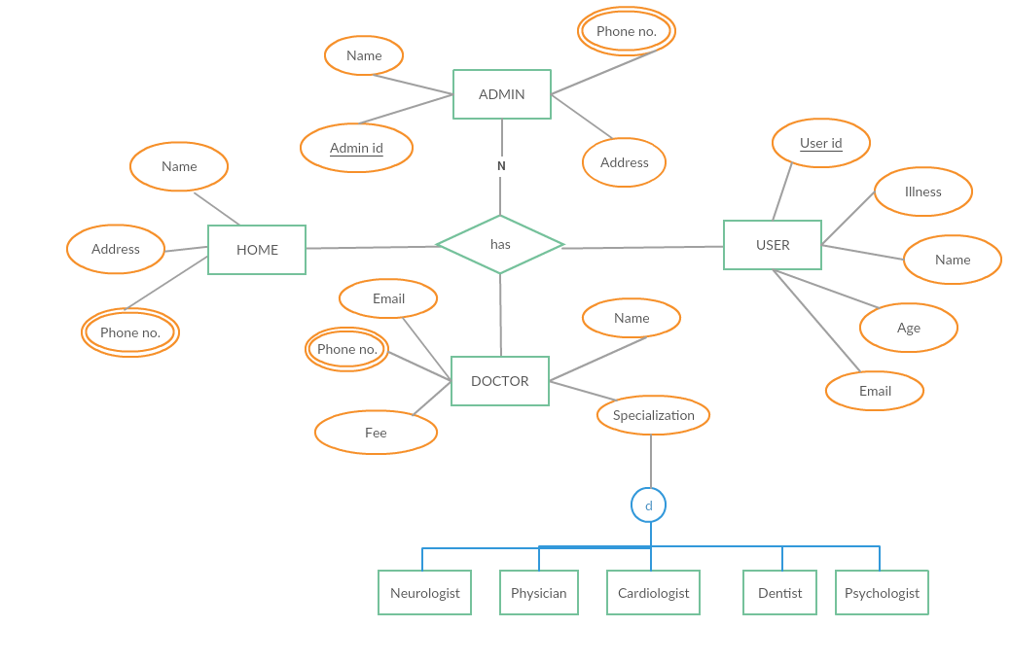
5.6 ER – Diagram
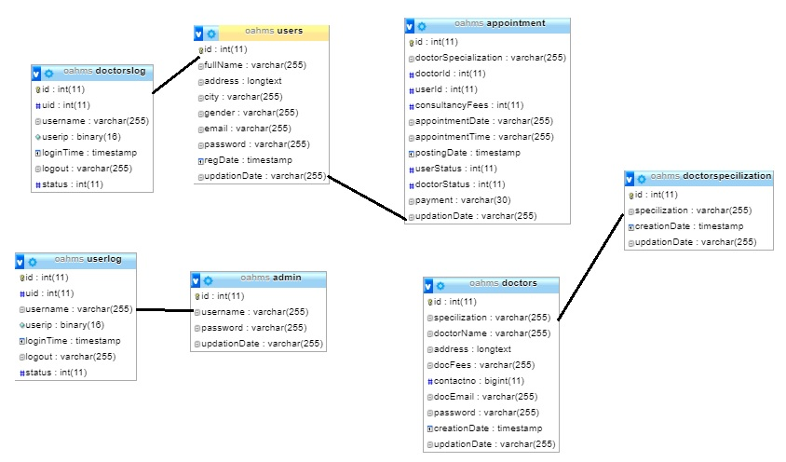

5.7 Process Model

Spiral Model
DEFINITION - The spiral model, also known as the spiral lifecycle model, is a systems development method (SDM) used in information technology (IT). This model of development combines the features of the prototyping model and the waterfall model. The spiral model is intended for large, expensive, and complicated projects.

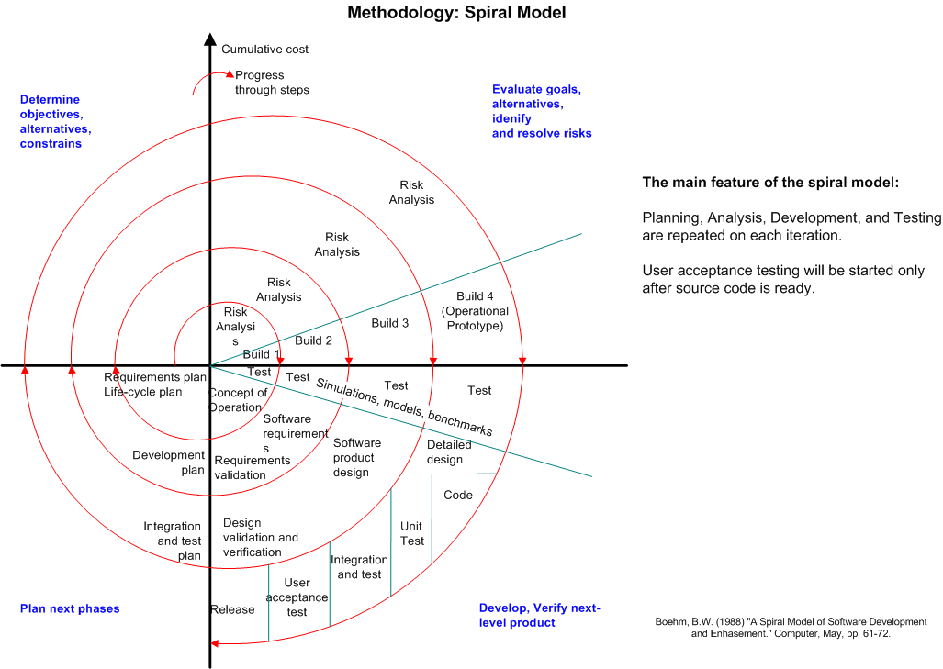
The steps in the spiral model can be generalized as follows:
- A preliminary design is created for the new system.

- A first prototype of the new system is constructed from the preliminary design. This is usually a scaled-down system, and represents an approximation of the characteristics of the final product.

- A second prototype is evolved by a fourfold procedure:
(I) evaluating the first prototype in terms of its strengths, weaknesses,
And risks;
(ii) Defining the requirements of the second prototype;
(iii) Planning and designing the second prototype;
(iv) Constructing and testing the second prototype.

- At the customer's option, the entire project can be aborted if the risk is deemed too great. Risk factors might involve development cost overruns, operating-cost miscalculation, or any other factor that could, in the customer's judgment, result in a less-than-satisfactory final product.

- The existing prototype is evaluated in the same manner as was the previous prototype, and, if necessary, another prototype is developed from it according to the fourfold procedure outlined above.

- The preceding steps are iterated until the customer is satisfied that the refined prototype represents the final product desired.

- The final system is constructed, based on the refined prototype.

- The final system is thoroughly evaluated and tested. Routine maintenance is carried out on a continuing basis to prevent large-scale failures and to minimize downtime.

Advantages
- Estimates (i.e. budget, schedule, etc.) get more realistic as work progresses, because important issues are discovered earlier.
- It is more able to cope with the (nearly inevitable) changes that software development generally entails.
- Software engineers (who can get restless with protracted design processes) can get their hands in and start working on a project earlier.

  - CODING

First phase of implementation is coding. Coding can be done in two ways. One by automatic program code and other by programmer’s manually written code. A code generator is a suite of programs that matches the input to an appropriate code template and from these produces modules of code.
The code is made simple in such a way that another programmer can easily understand and work on that in future. The crucial phase in the system development life cycle is the successful implementation of the new system design. The process of converting as new or revised system into an operational one is known as system implementation.
This includes all those activities that take place to convert from an old system to a new system. The system can be implemented only after a through testing is done and if it is found to work according to the specifications. The most crucial stage in achieving a new successful system and giving confident on the new system for the users is that it will work effectively and efficiently. If involves careful planning, investigation of the current system and its constraints on implementation, design of methods to achieve the change over.

SOURCE CODE

HOME PAGE

<!DOCTYPE html>
<html lang="en">

<head>
<meta charset="utf-8">
<meta http-equiv="X-UA-Compatible" content="IE=edge">
<meta name="viewport" content="width=device-width, initial-scale=1">
<title>Home</title>

<!-- Css Folder -->
<link href="css/bootstrap.css" rel="stylesheet">
<link href="css/bootstrap-theme.css" rel="stylesheet">
<link href="css/font-awesome.css" rel="stylesheet">
<link href="css/color.css" rel="stylesheet">
<link href="style.css" rel="stylesheet">
<link href="css/responsive.css" rel="stylesheet">
<link href="css/themetypo.css" rel="stylesheet">
<link href="css/bxslider.css" rel="stylesheet">
<link href="css/datepicker.css" rel="stylesheet">

<!-- HTML5 shim and Respond.js for IE8 support of HTML5 elements and media queries -->
<!-- WARNING: Respond.js doesn't work if you view the page via file:// -->
<!--[if lt IE 9]>
<script src="https://oss.maxcdn.com/html5shiv/3.7.2/html5shiv.min.js"></script>
<script src="https://oss.maxcdn.com/respond/1.4.2/respond.min.js"></script>
<![endif]-->
</head>
<body>

<header id="mainheader">
<!--// Top Baar //-->
<div class="kd-topbar">
<div class="container">
<div class="row">
<div class="col-md-7">
<ul class="kd-topinfo">

<li>
<i class="fa fa-phone"></i> Phone: +91 8152965830
</li>
<li>
<i class="fa fa-envelope-o"></i> <a href="#">Email:rajat@oldagehome.com</a>
</li>
</ul>
</div>
<div class="col-md-5">
<ul class="kd-userinfo">

<li><a href="#" data-toggle="modal" data-target="#registerModalbox"><a href="hms/admin">Admin Login</a>

</li>
<li><a href="#" data-toggle="modal" data-target="#Modalbox"><a href="hms/doctor">Doctor Login</a>

</li>
<li><a href="#" data-toggle="modal" data-target="#Modalbox"><a href="hms/user-login.php">User Login</a>
</li>
</ul>
</div>
</div>
</div>
</div>

<!--// Top Baar //-->

<!--// Header Baar //-->
<div class="kd-headbar">
<div class="container">
<div class="row">
<div class="col-md-3"><a href="index.html" class="logo"><img src="images/logo.png" alt=""></a></div>
<div class="col-md-9">
<div class="kd-rightside">
<nav class="navbar navbar-default navigation">
<div class="navbar-header">
<button type="button" class="navbar-toggle collapsed" data-toggle="collapse" data-target="#navbar-collapse-1">
<span class="icon-bar"></span>
<span class="icon-bar"></span>
<span class="icon-bar"></span>
</button>
</div>

<div class="collapse navbar-collapse" id="navbar-collapse-1">
<ul class="nav navbar-nav">
<li><a href="index.php">Home</a>

</li>
<li><a href="About.html">About Us</a>

</li>
<li><a href="Services.html">Our Services</a>

</li>
<li><a href="gallery.html">Gallery</a>

</li>
<li><a href="Donation.html">Donation</a>

</li>
<li><a href="contact-us.html">contact us</a></li>
</ul>
</div>
<!-- /.navbar-collapse -->
</nav>

</div>
</div>
</div>
</div>
</div>
<!--// Header Baar //-->

</header>

<!--// MainBanner //-->
<div id="mainbanner">
<ul class="bxslider">
<li><img src="extraimages/banner1.jpg" alt="" />
<div class="carousel-caption">
<h3>Old people were young people even before young people were people!!</h3>
<h4>In the evening of their lives</h4>
<h4>Help Us Help Them...</h4>
</div>

</li>
<li><img src="extraimages/banner2.jpg" alt="" />
<div class="carousel-caption">
<h3>Love your mother… you will never get another!!</h3>
<h4>In the evening of their lives</h4>
<h4>Help Us Help Them...</h4>
</div>

</li>
<li><img src="extraimages/banner3.jpg" alt="" />
<div class="carousel-caption">
<h3>Fathers are heroes whose guiding light shows us the way of life!!</h3>
<h4>In the evening of their lives</h4>
<h4>Help Us Help Them&#8230;</h4>
</div>
</li>
<li><img src="extraimages/banner4.jpg" alt="" />
<div class="carousel-caption">
<h3>A womb that left her marks and a walking stick that showed her here!!</h3>
<h4>In the evening of their lives</h4>
<h4>Help Us Help Them...</h4>
</div>

</ul>

</div>
<!--// MainBanner //-->

<!--// Content //-->
<div class="kd-content">

<!--// Page Section //-->
<section class="kd-pagesection">
<div class="container">
<div class="row">

<div class="col-md-12">
<div class="kd-modrentitle thememargin">
<h3>-: What we do :-</h3>
<div class="kd-divider"><div class="short-seprator"><span><i class="fa fa-home"></i></span></div></div>
<br />
<h5>Old Age Home was established in 1989 the mission was one-to care helpless and hapless.
The primary objective of organization is to advocate, care, teach and serve them with compassion, kindness and respect for bringing happiness in their lives.
The people and staffs who associated with us do not work as profession but they just serve the needy with enthusiasm and passion. Our primary aim is to offer long term health care needs to your family and friends. </h5>
<h5>Testimonials and Feedback of patients and their family members are the most significant ways for making improvement in quality of services.
Hence, we welcome patients and their family members to ask question and participate in deciding about their care and wellbeing.
Apart from home care, our organization also has two assisted living facilities which can accommodate 45 bed ridden patients and walkable old age person who need 24-hour nursing attention.
Our staffs are very happy to work with infirm elders or disable because it is the most rewarding job and offer inner satisfaction. </h5>
</div>
</div>
</div>
</div>
</section>
<!--// Page Section //-->

<!--// Page Section //-->
<section class="kd-pagesection" style=" padding: 20px 0px 0px 0px; background: #fcfcfc; ">
<div class="container">
<div class="row">

<div class="col-md-12">
<div class="kd-modrentitle thememargin">
<h3>-: Why Only Us :-</h3>
<div class="kd-divider"><div class="short-seprator"><span><i class="fa fa-globe"></i></span></div></div>
<br />
<h5>we don’t publicize our achievements unlike others. We believe in doing silent good work which we know will bring us laurels. We, have developed a good reputation in the community by offering high-class and long term care services to the needy who come to us. We provide various types of services such as Elder Care, Dementia Care, Respite Care, Long Term Care, Assisted Living, etc. In order to get quality service, you can bank on us. We are backed by a team of qualified and experienced doctors, psychiatrists, psychologist, trainers, counselor, social workers and other staffs who are serving the society with honesty and dedication. These qualified staffs help us in offering high-quality nursing and social care services </h5>
<h5>for offering better-quality services, we train, tune and sensitize our staffs who are loyal and show hundred percent commitments towards their responsibilities. We always bond with promises because we don’t want to mislead the clients by offering them moon. We are fully focused on delivering the finest services. We are happy over our achievements and if any one degrades us about working with older or the disabled people, we respond simply by saying that it is enjoyable, as well as being the most commendable job anyone can have. We treat this as passion. We show sympathy, respect and dignity to the people we encounter, which means always being aware of the fact that we are in someone Else's home.</h5>

</div>

</div>
</div>
</div>
<!--// Page Section //-->

</div>
<!--// Content //-->

<!--// Footer //-->

<!--// Footer //-->

<!--// CopyRight //-->
<div id="copyright">
<div class="container">
<div class="row">
<div class="col-md-12 text-center"><p><strong>© Copyright 2019 All Rights Reserved</strong></p></div>

</div>
</div>
</div>
<!--// CopyRight //-->

<!-- jQuery (Necessary For JavaScript Plugins) -->
<script src="js/jquery.js"></script>
<script src="js/bootstrap.min.js"></script>
<script src="js/jquery.bxslider.min.js"></script>
<script src="js/bootstrap-datepicker.js"></script>
<script src="js/waypoints-min.js"></script>
<script src="js/functions.js"></script>
</body>

</html>

SERVICES PAGE

<!DOCTYPE html>
<html lang="en">
<head>
<meta charset="utf-8">
<meta http-equiv="X-UA-Compatible" content="IE=edge">
<meta name="viewport" content="width=device-width, initial-scale=1">
<title>Home</title>

<!-- Css Folder -->
<link href="css/bootstrap.css" rel="stylesheet">
<link href="css/bootstrap-theme.css" rel="stylesheet">
<link href="css/font-awesome.css" rel="stylesheet">
<link href="css/color.css" rel="stylesheet">
<link href="style.css" rel="stylesheet">
<link href="css/responsive.css" rel="stylesheet">
<link href="css/themetypo.css" rel="stylesheet">
<link href="css/bxslider.css" rel="stylesheet">
<link href="css/datepicker.css" rel="stylesheet">

<!-- HTML5 shim and Respond.js for IE8 support of HTML5 elements and media queries -->
<!-- WARNING: Respond.js doesn't work if you view the page via file:// -->
<!--[if lt IE 9]>
<script src="https://oss.maxcdn.com/html5shiv/3.7.2/html5shiv.min.js"></script>
<script src="https://oss.maxcdn.com/respond/1.4.2/respond.min.js"></script>
<![endif]-->
</head>
<body>

<header id="mainheader">
<!--// Top Baar //-->
<div class="kd-topbar">
<div class="container">
<div class="row">
<div class="col-md-7">
<ul class="kd-topinfo">

<li>
<i class="fa fa-phone"></i> Phone: +91 8152965830
</li>
<li>
<i class="fa fa-envelope-o"></i> <a href="#">Email:rajat@oldagehome.com</a>
</li>
</ul>
</div>
<div class="col-md-5">
<ul class="kd-userinfo">

<li><a href="#" data-toggle="modal" data-target="#registerModalbox"><a href="hms/admin">Admin Login</a>

</li>
<li><a href="#" data-toggle="modal" data-target="#Modalbox"><a href="hms/doctor">Doctor Login</a>

</li>
<li><a href="#" data-toggle="modal" data-target="#Modalbox"><a href="hms/user-login.php">User Login</a>
</li>
</ul>
</div>
</div>
</div>
</div>

<!--// Top Baar //-->

<!--// Header Baar //-->
<div class="kd-headbar">
<div class="container">
<div class="row">
<div class="col-md-3"><a href="index.html" class="logo"><img src="images/logo.png" alt=""></a></div>
<div class="col-md-9">
<div class="kd-rightside">
<nav class="navbar navbar-default navigation">
<div class="navbar-header">
<button type="button" class="navbar-toggle collapsed" data-toggle="collapse" data-target="#navbar-collapse-1">
<span class="icon-bar"></span>
<span class="icon-bar"></span>
<span class="icon-bar"></span>
</button>
</div>

<div class="collapse navbar-collapse" id="navbar-collapse-1">
<ul class="nav navbar-nav">
<li><a href="index.php">Home</a>

</li>
<li><a href="About.html">About Us</a>

</li>
<li><a href="Services.html">Our Services</a>

</li>
<li><a href="gallery.html">Gallery</a>

</li>
<li><a href="Donation.html">Donation</a>

</li>
<li><a href="contact-us.html">contact us</a></li>
</ul>
</div>
<!-- /.navbar-collapse -->
</nav>

</div>
</div>
</div>
</div>
</div>
<!--// Header Baar //-->

</header>

<!--// Sub Header //-->
<div class="kd-subheader">
<div class="container">
<div class="row">
<div class="col-md-12">

<div class="subheader-info">
<h1>OUR SERVICES</h1>
<!-- <p>Morbi euismod euismod consectetur. Donec pharetra, lacus at convallis maximus, arcu quam accumsan diam, et aliquam odio elit gravida mi</p> -->
</div>

</div>
</div>
</div>
</div>
<!--// Sub Header //-->

<!--// Content //-->
<div class="kd-content">
<!--// Page Section //-->
<section class="kd-pagesection">
<div class="container">
<div class="row">

<div class="col-md-12">
<div class="kd-modrentitle thememargin">
<h3><strong>-: services offered by OLD AGE HOME :-</strong></h3>
<div class="kd-divider"><div class="short-seprator"><span><i class="fa fa-home"></i></span></div></div>
<br />

<h5>It has become very common phenomenon for extended families and friends to be separated by great distances. New job opportunities force the adult children to move away from home. However, at some point in their lives, your parents, grandparents or a loved one will become unable to properly care for themselves. Suddenly you are faced the challenge of long distance Care giving. We, at Navachaithanya manage plenty of such situations and make life easier for children who are worried about the parents’ health and for their welfare.

<br><br>

Our professionals ready to give nursing care to your mother or father round the clock. You make a call to us any time for companionship to love one. We will ask you to send your immediate relative, a cousin or uncle or a close friend to the office to have preliminary discussion and evaluation of the clinical condition. In this preliminary meeting our professionals like psychologists, doctors, social workers and other staffs will discuss the prognosis, support systems currently available, emergency preparedness, family dynamics, chances of deterioration, chances of rehabilitation, support systems needed in case of deterioration of condition etc,. In short a care plan is drawn.

<br><br>

Your relative and friend can not give much time as they also have their own hectic schedules. To ease the burden, we provide Long Distance Care giving services to clients. These services are provided by those professionals who have credibility, competence and professionalism. Before you hire Navachaitanya, just evaluate the credibility of the organization and not those who offer moon.

You should find out how the service provider imparts training, what is the protocol regarding the replacements, how the grievance redressal system functions. Moreover, emergency response systems, ability to manage when the condition changes to a different level and availability of assisted living facility also matters when you chose a provider. Sitting in a far off place you should be able to access all these if required.
</div></div></div></div>

<div class="kd-lists">
<p><strong>OUR PUBLIC SERVICES</strong></p>
<ul>
<li>Conducting Free General Medical Camp</li>
<li>Free Eye Checkup Camp</li>
<li>Free Ayurvedic Camps</li>
<li>Free Optical &amp; Required Medicine Distributions.</li>
<li>Free Eye Surgery</li>
<li>Mobile Medical Services</li>
<li>Awareness &amp; Counseling Programmer</li>
<li>Mobile Medical Centre</li>
<li>HIV/AIDS awareness programmer</li>
<li>Immunization for Children /Adult Programmer</li>
<li>Road Safety Programmer ect.……………</li>
<br><br><br>
</ul>
<p><strong>FACILITIES WHAT WE OFFER</strong></p>
<ul>
<li>Old Age Home</li>
<li>Home for Mentally Disabled</li>
<li>Home for Handicapped</li>
<li>24/7 Nursing Care</li>
<li>Doctors Care</li>
<li>Food &amp; Accommodation</li>
<li>Clean &amp; Hygienic Facilities</li>
<li>Garden </li>
<li>Spacious, Secured, Comfortable and peaceful Environment</li>
</ul>
</div>
</div>
<!--// Content //-->

<!--// Footer //-->

<!--// Footer //-->

<!--// CopyRight //-->
<div id="copyright">
<div class="container">
<div class="row">
<div class="col-md-12 text-center"><p><strong>© Copyright 2019 All Rights Reserved</strong></p></div>

</div>
</div>
</div>
<!--// CopyRight //-->

<!-- jQuery (Necessary For JavaScript Plugins) -->
<script src="js/jquery.js"></script>
<script src="js/bootstrap.min.js"></script>
<script src="js/jquery.bxslider.min.js"></script>
<script src="js/bootstrap-datepicker.js"></script>
<script src="js/waypoints-min.js"></script>
<script src="js/jquery.accordion.js"></script>
<script src="js/functions.js"></script>
</body>
</html>

DONATION PAGE

<!DOCTYPE html>
<html lang="en">

<head>
<meta charset="utf-8">
<meta http-equiv="X-UA-Compatible" content="IE=edge">
<meta name="viewport" content="width=device-width, initial-scale=1">
<title>Home</title>

<!-- Css Folder -->
<link href="css/bootstrap.css" rel="stylesheet">
<link href="css/bootstrap-theme.css" rel="stylesheet">
<link href="css/font-awesome.css" rel="stylesheet">
<link href="css/color.css" rel="stylesheet">
<link href="style.css" rel="stylesheet">
<link href="css/responsive.css" rel="stylesheet">
<link href="css/themetypo.css" rel="stylesheet">
<link href="css/bxslider.css" rel="stylesheet">
<link href="css/datepicker.css" rel="stylesheet">

<!-- HTML5 shim and Respond.js for IE8 support of HTML5 elements and media queries -->
<!-- WARNING: Respond.js doesn't work if you view the page via file:// -->
<!--[if lt IE 9]>
<script src="https://oss.maxcdn.com/html5shiv/3.7.2/html5shiv.min.js"></script>
<script src="https://oss.maxcdn.com/respond/1.4.2/respond.min.js"></script>
<![endif]-->
</head>
<body>

<header id="mainheader">
<!--// Top Baar //-->
<div class="kd-topbar">
<div class="container">
<div class="row">
<div class="col-md-7">
<ul class="kd-topinfo">

<li>
<i class="fa fa-phone"></i> Phone: +91 8152965830
</li>
<li>
<i class="fa fa-envelope-o"></i> <a href="#">Email:rajat@oldagehome.com</a>
</li>
</ul>
</div>
<div class="col-md-5">
<ul class="kd-userinfo">

<li><a href="#" data-toggle="modal" data-target="#registerModalbox"><a href="hms/admin">Admin Login</a>

</li>
<li><a href="#" data-toggle="modal" data-target="#Modalbox"><a href="hms/doctor">Doctor Login</a>

</li>
<li><a href="#" data-toggle="modal" data-target="#Modalbox"><a href="hms/user-login.php">User Login</a>
</li>
</ul>
</div>
</div>
</div>
</div>

<!--// Top Baar //-->

<!--// Header Baar //-->
<div class="kd-headbar">
<div class="container">
<div class="row">
<div class="col-md-3"><a href="index.html" class="logo"><img src="images/logo.png" alt=""></a></div>
<div class="col-md-9">
<div class="kd-rightside">
<nav class="navbar navbar-default navigation">
<div class="navbar-header">
<button type="button" class="navbar-toggle collapsed" data-toggle="collapse" data-target="#navbar-collapse-1">
<span class="icon-bar"></span>
<span class="icon-bar"></span>
<span class="icon-bar"></span>
</button>
</div>

<div class="collapse navbar-collapse" id="navbar-collapse-1">
<ul class="nav navbar-nav">
<li><a href="index.php">Home</a>

</li>
<li><a href="About.html">About Us</a>

</li>
<li><a href="Services.html">Our Services</a>

</li>
<li><a href="gallery.html">Gallery</a>

</li>
<li><a href="Donation.html">Donation</a>

</li>
<li><a href="contact-us.html">contact us</a></li>
</ul>
</div>
<!-- /.navbar-collapse -->
</nav>

</div>
</div>
</div>
</div>
</div>
<!--// Header Baar //-->

</header>

<!--// Sub Header //-->
<div class="kd-subheader">
<div class="container">
<div class="row">
<div class="col-md-12">

<div class="subheader-info">
<h1>DONATION</h1>
<!-- <p>Morbi euismod euismod consectetur. Donec pharetra, lacus at convallis maximus, arcu quam accumsan diam, et aliquam odio elit gravida mi</p> -->
</div>

</div>
</div>
</div>
</div>
<!--// Sub Header //-->

<!--// Content //-->
<div class="kd-content">
<td width="600px" bgcolor="#ffffff" valign="top">
<div id="margin_web">
<!--contents start-->
<table cellpadding="0" cellspacing="0" border="0" width="580">
<tbody><tr>
<td width="217" style="background-image:url(images/menu.jpg)" height="31" id="menu">&nbsp; DONATION ::-</td>
<td width="363"><div align="right" style="margin-right:15px;"><a href="?page=donation"><img src="images/make_donation.jpg" border="0"></a></div></td>
</tr>
<tr>
<td colspan="2"><strong>The donations made to Old Age Home Trust are tax deductible under section 80G(2)(a)(iv) r.w.s. 80G(5)(vi) of the income-tax Act.1961 in the hands of the donors</strong></td>
</tr>
<tr>
<td valign="top" style="border:1px solid #CCCCCC">
<div class="txt" style="padding-left:15px; line-height:22px">
<strong><br>
MICR CODE :<br>
IFSC CODE SBI <br>
SWIFT CODE SBI<br>
ACCOUNT NAME : <br>
ACCOUNT NUMBER : <br>
BRANCH CODE :<br>
BRANCH : </strong></div></td>
<td valign="top" class="txt" style="border:1px solid #CCCCCC">
<div style="padding-left:15px; line-height:22px"><br>
560002515<br>
<strong>SBINOO40807</strong><br>
<strong>SBININBBM03</strong><br>
Old Age Home TRUST<br>
31205695561<br>
40807<br>
State Bank of India<br>
Horamavu Branch Banaswadi Bangalore, India<br>&nbsp;</div></td>
</tr>

<tr>
<td colspan="2" height="10px">&nbsp;</td>
</tr>
<tr>
<td colspan="2" height="10px">&nbsp;</td>
</tr>
<tr>
<td colspan="2" height="10px"> </td>
</tr>
</tbody></table>

<!--end content-->
</div> </td>
</div>
<!--// Content //-->

<!--// Footer //-->

<!--// Footer //-->

<!--// CopyRight //-->
<div id="copyright">
<div class="container">
<div class="row">
<div class="col-md-12 text-center"><p>© Copyright 2018 All Rights Reserved </p></div>

</div>
</div>
</div>
<!--// CopyRight //-->

<!-- jQuery (Necessary For JavaScript Plugins) -->
<script src="js/jquery.js"></script>
<script src="js/bootstrap.min.js"></script>
<script src="js/jquery.bxslider.min.js"></script>
<script src="js/bootstrap-datepicker.js"></script>
<script src="js/waypoints-min.js"></script>
<script src="js/jquery.accordion.js"></script>
<script src="js/functions.js"></script>
</body>
</html>

USER_LOGIN PAGE
<?php
session_start();
error_reporting(0);
include("include/config.php");
if(isset($_POST['submit']))
{
$ret=mysqli_query($con,"SELECT * FROM users WHERE email='".$_POST['username']."' and password='".($_POST['password'])."'");
$num=mysqli_fetch_array($ret);
if($num>0)
{
$extra="dashboard.php";//
$_SESSION['login']=$_POST['username'];
$_SESSION['id']=$num['id'];
$host=$_SERVER['HTTP_HOST'];
$uip=$_SERVER['REMOTE_ADDR'];
$status=1;
// For stroing log if user login successfull
$log=mysqli_query($con,"insert into userlog(uid,username,userip,status) values('".$_SESSION['id']."','".$_SESSION['login']."','$uip','$status')");
$uri=rtrim(dirname($_SERVER['PHP_SELF']),'/\\');
header("location:http://$host$uri/$extra");
exit();
}
else
{
// For stroing log if user login unsuccessfull
$_SESSION['login']=$_POST['username'];
$uip=$_SERVER['REMOTE_ADDR'];
$status=0;
mysqli_query($con,"insert into userlog(username,userip,status) values('".$_SESSION['login']."','$uip','$status')");
$_SESSION['errmsg']="Invalid username or password";
$extra="user-login.php";
$host = $_SERVER['HTTP_HOST'];
$uri = rtrim(dirname($_SERVER['PHP_SELF']),'/\\');
header("location:http://$host$uri/$extra");
exit();
}
}
?>

<!DOCTYPE html>
<html lang="en">
<head>
<title>User-Login</title>
<meta charset="utf-8" />
<meta name="viewport" content="width=device-width, initial-scale=1.0, user-scalable=0, minimum-scale=1.0, maximum-scale=1.0">
<meta name="apple-mobile-web-app-capable" content="yes">
<meta name="apple-mobile-web-app-status-bar-style" content="black">
<meta content="" name="description" />
<meta content="" name="author" />
<link href="http://fonts.googleapis.com/css?family=Lato:300,400,400italic,600,700|Raleway:300,400,500,600,700|Crete+Round:400italic" rel="stylesheet" type="text/css" />
<link rel="stylesheet" href="vendor/bootstrap/css/bootstrap.min.css">
<link rel="stylesheet" href="vendor/fontawesome/css/font-awesome.min.css">
<link rel="stylesheet" href="vendor/themify-icons/themify-icons.min.css">
<link href="vendor/animate.css/animate.min.css" rel="stylesheet" media="screen">
<link href="vendor/perfect-scrollbar/perfect-scrollbar.min.css" rel="stylesheet" media="screen">
<link href="vendor/switchery/switchery.min.css" rel="stylesheet" media="screen">
<link rel="stylesheet" href="assets/css/styles.css">
<link rel="stylesheet" href="assets/css/plugins.css">
<link rel="stylesheet" href="assets/css/themes/theme-1.css" id="skin_color" />
</head>
<body class="login">
<div class="row">
<div class="main-login col-xs-10 col-xs-offset-1 col-sm-8 col-sm-offset-2 col-md-4 col-md-offset-4">
<div class="logo margin-top-30">
<a href="../index.html"><h2> OAHMS | Patient Login</h2></a>
</div>

<div class="box-login">
<form class="form-login" method="post">
<fieldset>
<legend>
Sign in to your account
</legend>
<p>
Please enter your name and password to log in.<br />
<span style="color:red;"><?php echo $_SESSION['errmsg']; ?><?php echo $_SESSION['errmsg']="";?></span>
</p>
<div class="form-group">
<span class="input-icon">
<input type="text" class="form-control" name="username" placeholder="Username">
<i class="fa fa-user"></i> </span>
</div>
<div class="form-group form-actions">
<span class="input-icon">
<input type="password" class="form-control password" name="password" pattern=".{6,}" placeholder="Password-Six or more characters">
<i class="fa fa-lock"></i>
</span>
</div>
<div class="form-actions">

<button type="submit" class="btn btn-primary pull-right" name="submit">
Login <i class="fa fa-arrow-circle-right"></i>
</button>
</div>
<div class="new-account">
Don't have an account yet?
<a href="registration.php">
Create an account
</a>
</div>

<div class="new-account">

<h3>Go to <a href="../index.php">Home<i class="fa fa-home"></i> </a> </h3>
</div>

</fieldset>
</form>

<div class="copyright">
&copy; <span class="current-year"></span><span class="text-bold text-uppercase"> OAHMS</span>. <span>All rights reserved</span>
</div>

</div>

</div>
</div>
<script src="vendor/jquery/jquery.min.js"></script>
<script src="vendor/bootstrap/js/bootstrap.min.js"></script>
<script src="vendor/modernizr/modernizr.js"></script>
<script src="vendor/jquery-cookie/jquery.cookie.js"></script>
<script src="vendor/perfect-scrollbar/perfect-scrollbar.min.js"></script>
<script src="vendor/switchery/switchery.min.js"></script>
<script src="vendor/jquery-validation/jquery.validate.min.js"></script>

<script src="assets/js/main.js"></script>

<script src="assets/js/login.js"></script>
<script>
jQuery(document).ready(function() {
Main.init();
Login.init();
});
</script>

</body>
<!-- end: BODY -->
</html>

ADMIN LOGIN PAGE

<?php
session_start();
error_reporting(0);
include("include/config.php");
if(isset($_POST['submit']))
{
$ret=mysqli_query($con,"SELECT * FROM admin WHERE username='".$_POST['username']."' and password='".$_POST['password']."'");
$num=mysqli_fetch_array($ret);
if($num>0)
{
$extra="dashboard.php";//
$_SESSION['login']=$_POST['username'];
$_SESSION['id']=$num['id'];
$host=$_SERVER['HTTP_HOST'];
$uri=rtrim(dirname($_SERVER['PHP_SELF']),'/\\');
header("location:http://$host$uri/$extra");
exit();
}
else
{
$_SESSION['errmsg']="Invalid username or password";
$extra="index.php";
$host = $_SERVER['HTTP_HOST'];
$uri = rtrim(dirname($_SERVER['PHP_SELF']),'/\\');
header("location:http://$host$uri/$extra");
exit();
}
}
?>

<!DOCTYPE html>
<html lang="en">
<head>
<title>Admin-Login</title>
<meta charset="utf-8" />
<meta name="viewport" content="width=device-width, initial-scale=1.0, user-scalable=0, minimum-scale=1.0, maximum-scale=1.0">
<meta name="apple-mobile-web-app-capable" content="yes">
<meta name="apple-mobile-web-app-status-bar-style" content="black">
<meta content="" name="description" />
<meta content="" name="author" />
<link href="http://fonts.googleapis.com/css?family=Lato:300,400,400italic,600,700|Raleway:300,400,500,600,700|Crete+Round:400italic" rel="stylesheet" type="text/css" />
<link rel="stylesheet" href="vendor/bootstrap/css/bootstrap.min.css">
<link rel="stylesheet" href="vendor/fontawesome/css/font-awesome.min.css">
<link rel="stylesheet" href="vendor/themify-icons/themify-icons.min.css">
<link href="vendor/animate.css/animate.min.css" rel="stylesheet" media="screen">
<link href="vendor/perfect-scrollbar/perfect-scrollbar.min.css" rel="stylesheet" media="screen">
<link href="vendor/switchery/switchery.min.css" rel="stylesheet" media="screen">
<link rel="stylesheet" href="assets/css/styles.css">
<link rel="stylesheet" href="assets/css/plugins.css">
<link rel="stylesheet" href="assets/css/themes/theme-1.css" id="skin_color" />
</head>
<body class="login">
<div class="row">
<div class="main-login col-xs-10 col-xs-offset-1 col-sm-8 col-sm-offset-2 col-md-4 col-md-offset-4">
<div class="logo margin-top-30">
<h2>OAHMS | Admin Login</h2>
</div>

<div class="box-login">
<form class="form-login" method="post">
<fieldset>
<legend>
Sign in to your account
</legend>
<p>
Please enter your name and password to log in.<br />
<span style="color:red;"><?php echo htmlentities($_SESSION['errmsg']); ?><?php echo htmlentities($_SESSION['errmsg']="");?></span>
</p>
<div class="form-group">
<span class="input-icon">
<input type="text" class="form-control" name="username" placeholder="Username">
<i class="fa fa-user"></i> </span>
</div>
<div class="form-group form-actions">
<span class="input-icon">
<input type="password" class="form-control password" name="password" placeholder="Password"><i class="fa fa-lock"></i>
</span>
</div>
<div class="form-actions">

<button type="submit" class="btn btn-primary pull-right" name="submit">
Login <i class="fa fa-arrow-circle-right"></i>
</button>
</div>
<div class="new-account">

<h3>Go to <a href="./index.php">Home<i class="fa fa-home"></i> </a> </h3>
</div>

</fieldset>
</form>

<div class="copyright">
&copy; <span class="current-year"></span><span class="text-bold text-uppercase"> HMS</span>. <span>All rights reserved</span>
</div>

</div>

</div>
</div>
<script src="vendor/jquery/jquery.min.js"></script>
<script src="vendor/bootstrap/js/bootstrap.min.js"></script>
<script src="vendor/modernizr/modernizr.js"></script>
<script src="vendor/jquery-cookie/jquery.cookie.js"></script>
<script src="vendor/perfect-scrollbar/perfect-scrollbar.min.js"></script>
<script src="vendor/switchery/switchery.min.js"></script>
<script src="vendor/jquery-validation/jquery.validate.min.js"></script>

<script src="assets/js/main.js"></script>

<script src="assets/js/login.js"></script>
<script>
jQuery(document).ready(function() {
Main.init();
Login.init();
});
</script>

</body>
<!-- end: BODY -->
</html>

<?php
session_start();
include("include/config.php");
if(isset($_POST['submit']))
{
$ret=mysqli_query($con,"SELECT * FROM doctors WHERE docEmail='".$_POST['username']."' and password='".$_POST['password']."'");
$num=mysqli_fetch_array($ret);
if($num>0)
{
$extra="dashboard.php";
$_SESSION['dlogin']=$_POST['username'];
$_SESSION['id']=$num['id'];
$uip=$_SERVER['REMOTE_ADDR'];
$status=1;
$log=mysqli_query($con,"insert into doctorslog(uid,username,userip,status) values('".$_SESSION['id']."','".$_SESSION['dlogin']."','$uip','$status')");
$host=$_SERVER['HTTP_HOST'];
$uri=rtrim(dirname($_SERVER['PHP_SELF']),'/\\');
header("location:http://$host$uri/$extra");
exit();
}
else
{
$host = $_SERVER['HTTP_HOST'];
$_SESSION['dlogin']=$_POST['username'];
$uip=$_SERVER['REMOTE_ADDR'];
$status=0;
mysqli_query($con,"insert into doctorslog(username,userip,status) values('".$_SESSION['dlogin']."','$uip','$status')");
$_SESSION['errmsg']="Invalid username or password";
$extra="index.php";
$uri = rtrim(dirname($_SERVER['PHP_SELF']),'/\\');
header("location:http://$host$uri/$extra");
exit();
}
}
?>

<!DOCTYPE html>
<html lang="en">
<head>
<title>Doctor Login</title>
<meta charset="utf-8" />
<meta name="viewport" content="width=device-width, initial-scale=1.0, user-scalable=0, minimum-scale=1.0, maximum-scale=1.0">
<meta name="apple-mobile-web-app-capable" content="yes">
<meta name="apple-mobile-web-app-status-bar-style" content="black">
<meta content="" name="description" />
<meta content="" name="author" />
<link href="http://fonts.googleapis.com/css?family=Lato:300,400,400italic,600,700|Raleway:300,400,500,600,700|Crete+Round:400italic" rel="stylesheet" type="text/css" />
<link rel="stylesheet" href="vendor/bootstrap/css/bootstrap.min.css">
<link rel="stylesheet" href="vendor/fontawesome/css/font-awesome.min.css">
<link rel="stylesheet" href="vendor/themify-icons/themify-icons.min.css">
<link href="vendor/animate.css/animate.min.css" rel="stylesheet" media="screen">
<link href="vendor/perfect-scrollbar/perfect-scrollbar.min.css" rel="stylesheet" media="screen">
<link href="vendor/switchery/switchery.min.css" rel="stylesheet" media="screen">
<link rel="stylesheet" href="assets/css/styles.css">
<link rel="stylesheet" href="assets/css/plugins.css">
<link rel="stylesheet" href="assets/css/themes/theme-1.css" id="skin_color" />
</head>
<body class="login">
<div class="row">
<div class="main-login col-xs-10 col-xs-offset-1 col-sm-8 col-sm-offset-2 col-md-4 col-md-offset-4">
<div class="logo margin-top-30">
<a href="../../index.html"> <h2> OAHMS | Doctor Login</h2></a>
</div>

<div class="box-login">
<form class="form-login" method="post">
<fieldset>
<legend>
Sign in to your account
</legend>
<p>
Please enter your name and password to log in.<br />
<span style="color:red;"><?php echo $_SESSION['errmsg']; ?><?php echo $_SESSION['errmsg']="";?></span>
</p>
<div class="form-group">
<span class="input-icon">
<input type="text" class="form-control" name="username" placeholder="Username">
<i class="fa fa-user"></i> </span>
</div>
<div class="form-group form-actions">
<span class="input-icon">
<input type="password" class="form-control password" name="password" placeholder="Password">
<i class="fa fa-lock"></i>
</span>
</div>
<div class="form-actions">

<button type="submit" class="btn btn-primary pull-right" name="submit">
Login <i class="fa fa-arrow-circle-right"></i>
</button>
</div>
<div class="new-account">

<h3>Go to <a href="http://localhost//oldage//index.php">Home<i class="fa fa-home"></i> </a> </h3>
</div>

</fieldset>
</form>

<div class="copyright">
&copy; <span class="current-year"></span><span class="text-bold text-uppercase"> OAHMS</span>. <span>All rights reserved</span>
</div>

</div>

</div>
</div>
<script src="vendor/jquery/jquery.min.js"></script>
<script src="vendor/bootstrap/js/bootstrap.min.js"></script>
<script src="vendor/modernizr/modernizr.js"></script>
<script src="vendor/jquery-cookie/jquery.cookie.js"></script>
<script src="vendor/perfect-scrollbar/perfect-scrollbar.min.js"></script>
<script src="vendor/switchery/switchery.min.js"></script>
<script src="vendor/jquery-validation/jquery.validate.min.js"></script>

<script src="assets/js/main.js"></script>

<script src="assets/js/login.js"></script>
<script>
jQuery(document).ready(function() {
Main.init();
Login.init();
});
</script>

</body>
<!-- end: BODY -->
</html>

<?php
session_start();
//error_reporting(0);
include('include/config.php');
include('include/checklogin.php');
check_login();

if(isset($_POST['submit']))
{ $docspecialization=$_POST['Doctorspecialization'];
$docname=$_POST['docname'];
$docaddress=$_POST['clinicaddress'];
$docfees=$_POST['docfees'];
$doccontactno=$_POST['doccontact'];
$docemail=$_POST['docemail'];
$password=md5($_POST['npass']);
$sql=mysqli_query($con,"insert into doctors(specilization,doctorName,address,docFees,contactno,docEmail,password) values('$docspecialization','$docname','$docaddress','$docfees','$doccontactno','$docemail','$password')");
if($sql)
{
echo "<script>alert('Doctor info added Successfully');</script>";
header('location:manage-doctors.php');

}
}
?>
<!DOCTYPE html>
<html lang="en">
<head>
<title>Admin | Add Doctor</title>
<meta charset="utf-8" />
<meta name="viewport" content="width=device-width, initial-scale=1.0, user-scalable=0, minimum-scale=1.0, maximum-scale=1.0">
<meta name="apple-mobile-web-app-capable" content="yes">
<meta name="apple-mobile-web-app-status-bar-style" content="black">
<meta content="" name="description" />
<meta content="" name="author" />
<link href="http://fonts.googleapis.com/css?family=Lato:300,400,400italic,600,700|Raleway:300,400,500,600,700|Crete+Round:400italic" rel="stylesheet" type="text/css" />
<link rel="stylesheet" href="vendor/bootstrap/css/bootstrap.min.css">
<link rel="stylesheet" href="vendor/fontawesome/css/font-awesome.min.css">
<link rel="stylesheet" href="vendor/themify-icons/themify-icons.min.css">
<link href="vendor/animate.css/animate.min.css" rel="stylesheet" media="screen">
<link href="vendor/perfect-scrollbar/perfect-scrollbar.min.css" rel="stylesheet" media="screen">
<link href="vendor/switchery/switchery.min.css" rel="stylesheet" media="screen">
<link href="vendor/bootstrap-touchspin/jquery.bootstrap-touchspin.min.css" rel="stylesheet" media="screen">
<link href="vendor/select2/select2.min.css" rel="stylesheet" media="screen">
<link href="vendor/bootstrap-datepicker/bootstrap-datepicker3.standalone.min.css" rel="stylesheet" media="screen">
<link href="vendor/bootstrap-timepicker/bootstrap-timepicker.min.css" rel="stylesheet" media="screen">
<link rel="stylesheet" href="assets/css/styles.css">
<link rel="stylesheet" href="assets/css/plugins.css">
<link rel="stylesheet" href="assets/css/themes/theme-1.css" id="skin_color" />
<script type="text/javascript">
function valid()
{
if(document.adddoc.npass.value!= document.adddoc.cfpass.value)
{
alert("Password and Confirm Password Field do not match !!");
document.adddoc.cfpass.focus();
return false;
}
return true;
}
</script>

</head>
<body>
<div id="app">
<?php include('include/sidebar.php');?>
<div class="app-content">

<?php include('include/header.php');?>

<!-- end: TOP NAVBAR -->
<div class="main-content" >
<div class="wrap-content container" id="container">
<!-- start: PAGE TITLE -->
<section id="page-title">
<div class="row">
<div class="col-sm-8">
<h1 class="mainTitle">Admin | Add Doctor</h1>
</div>
<ol class="breadcrumb">
<li>
<span>Admin</span>
</li>
<li class="active">
<span>Add Doctor</span>
</li>
</ol>
</div>
</section>
<!-- end: PAGE TITLE -->
<!-- start: BASIC EXAMPLE -->
<div class="container-fluid container-fullw bg-white">
<div class="row">
<div class="col-md-12">

<div class="row margin-top-30">
<div class="col-lg-8 col-md-12">
<div class="panel panel-white">
<div class="panel-heading">
<h5 class="panel-title">Add Doctor</h5>
</div>
<div class="panel-body">

<form role="form" name="adddoc" method="post" onSubmit="return valid();">
<div class="form-group">
<label for="DoctorSpecialization">
Doctor Specialization
</label>
<select name="Doctorspecialization" class="form-control" required="required">
<option value="">Select Specialization</option>
<?php $ret=mysqli_query($con,"select * from doctorspecilization");
while($row=mysqli_fetch_array($ret))
{
?>
<option value="<?php echo htmlentities($row['specilization']);?>">
<?php echo htmlentities($row['specilization']);?>
</option>
<?php } ?>

</select>
</div>

<div class="form-group">
<label for="doctorname">
Doctor Name
</label>
<input type="text" name="docname" class="form-control" placeholder="Enter Doctor Name">
</div>

<div class="form-group">
<label for="address">
Doctor Clinic Address
</label>
<textarea name="clinicaddress" class="form-control" placeholder="Enter Doctor Clinic Address"></textarea>
</div>
<div class="form-group">
<label for="fess">
Doctor Consultancy Fees
</label>
<input type="text" name="docfees" class="form-control" placeholder="Enter Doctor Consultancy Fees">
</div>

<div class="form-group">
<label for="fess">
Doctor Contact no
</label>
<input type="text" name="doccontact" class="form-control" placeholder="Enter Doctor Contact no">
</div>

<div class="form-group">
<label for="fess">
Doctor Email
</label>
<input type="email" name="docemail" class="form-control" placeholder="Enter Doctor Email id">
</div>

<div class="form-group">
<label for="exampleInputPassword1">
Password
</label>
<input type="password" name="npass" class="form-control" placeholder="New Password" required="required">
</div>

<div class="form-group">
<label for="exampleInputPassword2">
Confirm Password
</label>
<input type="password" name="cfpass" class="form-control" placeholder="Confirm Password" required="required">
</div>

<button type="submit" name="submit" class="btn btn-o btn-primary">
Submit
</button> </form>
</div>
</div>
</div>
</div> </div>
<div class="col-lg-12 col-md-12">
<div class="panel panel-white">
</div>
</div>
</div>
</div>
</div>
</div>
<!-- end: BASIC EXAMPLE --
<!-- end: SELECT BOXES -->

</div>
</div>
</div>
<!-- start: FOOTER -->
<?php include('include/footer.php');?>
<!-- end: FOOTER -->

<!-- start: SETTINGS -->
<?php include('include/setting.php');?>
<>
<!-- end: SETTINGS -->
</div>
<!-- start: MAIN JAVASCRIPTS -->
<script src="vendor/jquery/jquery.min.js"></script>
<script src="vendor/bootstrap/js/bootstrap.min.js"></script>
<script src="vendor/modernizr/modernizr.js"></script>
<script src="vendor/jquery-cookie/jquery.cookie.js"></script>
<script src="vendor/perfect-scrollbar/perfect-scrollbar.min.js"></script>
<script src="vendor/switchery/switchery.min.js"></script>
<!-- end: MAIN JAVASCRIPTS -->
<!-- start: JAVASCRIPTS REQUIRED FOR THIS PAGE ONLY -->
<script src="vendor/maskedinput/jquery.maskedinput.min.js"></script>
<script src="vendor/bootstrap-touchspin/jquery.bootstrap-touchspin.min.js"></script>
<script src="vendor/autosize/autosize.min.js"></script>
<script src="vendor/selectFx/classie.js"></script>
<script src="vendor/selectFx/selectFx.js"></script>
<script src="vendor/select2/select2.min.js"></script>
<script src="vendor/bootstrap-datepicker/bootstrap-datepicker.min.js"></script>
<script src="vendor/bootstrap-timepicker/bootstrap-timepicker.min.js"></script>
<!-- end: JAVASCRIPTS REQUIRED FOR THIS PAGE ONLY -->
<!-- start: CLIP-TWO JAVASCRIPTS -->
<script src="assets/js/main.js"></script>
<!-- start: JavaScript Event Handlers for this page -->
<script src="assets/js/form-elements.js"></script>
<script>
jQuery(document).ready(function() {
Main.init();
FormElements.init();
});
</script>
<!-- end: JavaScript Event Handlers for this page -->
<!-- end: CLIP-TWO JAVASCRIPTS -->
</body>
</html>

7. TESTING
Testing is a process to show the correctness of the program. Testing is needed to show completeness, it improve the quality of the software and to provide the maintenance aid. Some testing standards are therefore necessary reduce the testing costs and operation time. Testing software extends throughout the coding phase and it represents the ultimate review of configurations, design and coding. Based on the way the software reacts to these testing, we can decide whether the configuration that has been built is study or not. All components of an application are tested, as the failure to do so many results in a series of bugs after the software is put to use.

7.1 Blackbox Testing
Blackbox testing, also called behavioral testing, focuses on the functional requirements of software. This testing approach enables the software engineer to derive the input conditions that will fully exercise all requirements for a program. Blackbox testing attempts to find the errors like
- Incorrect or missing functions
- Interface errors
- Errors in datastructures or external database access
- Behavior or performance errors
- Initialization and termination errors
In Blackbox testing software is exercised over a full range of inputs and outputs are observed for correctness.

7.2 Whitebox Testing
Whitebox testing is also called Glassbox testing is a test case design control; structure of the procedural design to derive test cases using Whitebox testing method, the software engineer can derive the test cases that guarantee that all independent paths within the module have been exercised at least once. Exercise all logic decisions on their true or false sides. Execute all loops at their boundaries and within their operational bounds. Exercise internal datastructure to ensure their validity.

7.3 Software Testing Strategies
Testing involves
- Unit testing
- Integration testing
- Acceptance testing

The first level of test is unit testing. The purpose of unit testing is to ensure that each program is fully tested.
The second step is integration testing. In this individual program units or programs are integrated and tested as a complete system to ensure that the software requirements are met.
Acceptance Testing involves planning and the execution of various types of tests in order to demonstrate that the implemented software system satisfies the requirements. Finally our project meets the requirements after going through all the levels of testing.

8. SECURITY
The system security problem can be divided into four related issues: security, integrity, privacy and confidentiality. They determine the file structure, data structure and access procedures.

System security refers to the technical innovations and procedures applied to the hardware and operating systems to protect against deliberate or accidental damage from a defined threat. In contrast, data security is the protection of data from loss, disclosure, modifications and destruction
.
System integrity refers to the proper functioning of programs, appropriate physical security and safety against external threats such as eavesdropping and wiretapping. In comparison, data integrity makes sure that do not differ from original from others and how the organization can be protected against unwelcome, unfair or excessive dissemination of information about it.

The term confidentiality is a special status given to sensitive information in a data base to minimize the possible invasion of privacy. It is an attribute of information that characterizes its need for protection. System security is the technical means of providing such protection. In contrast privacy is largely a procedural matter of how information is used.

9. SCREEN SHOTS
HOME PAGE
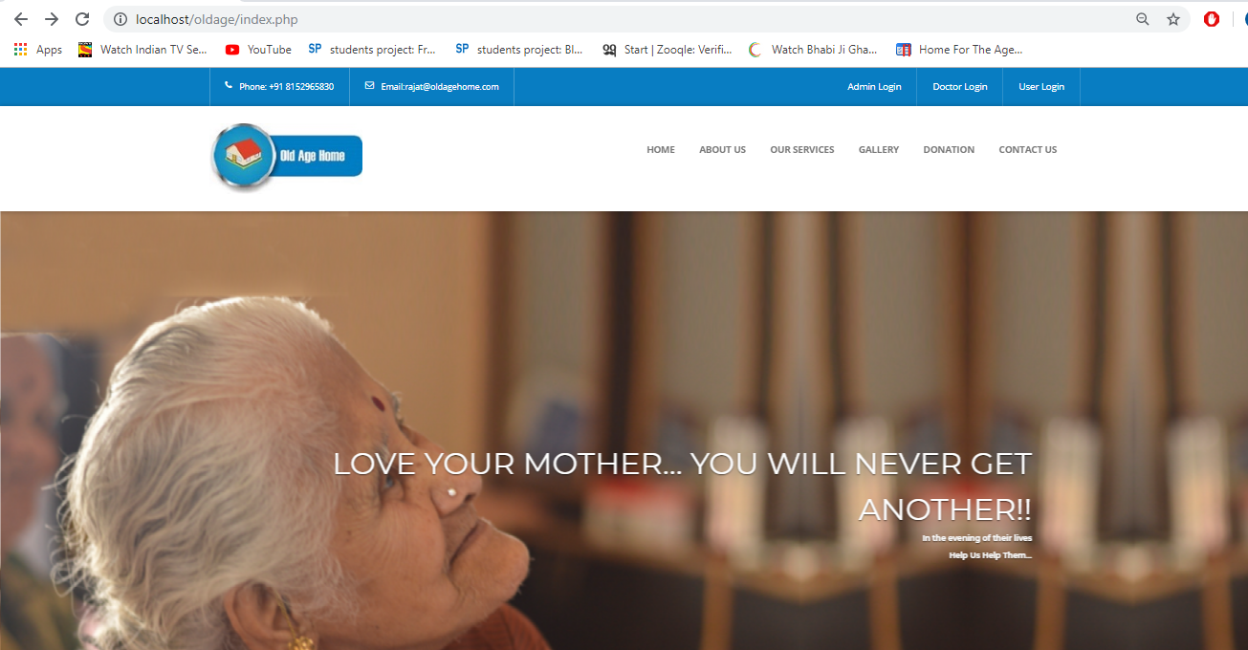
ADMIN LOGIN
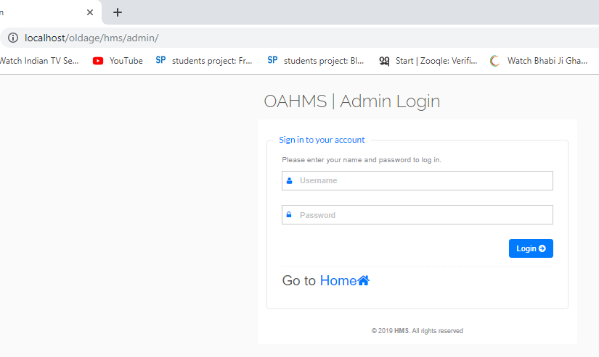

DOCTOR LOGIN

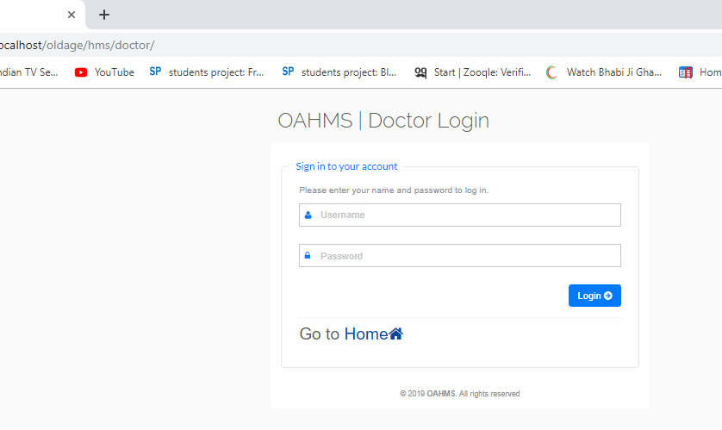
USER LOGIN

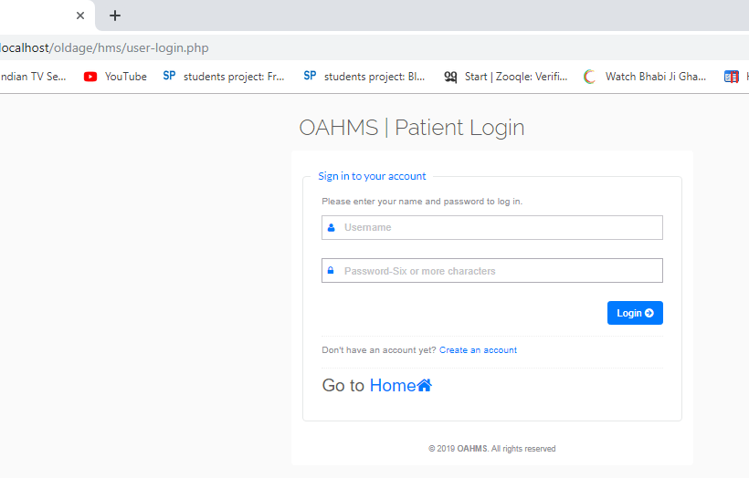

DOCTOR DASHBOARD PAGE

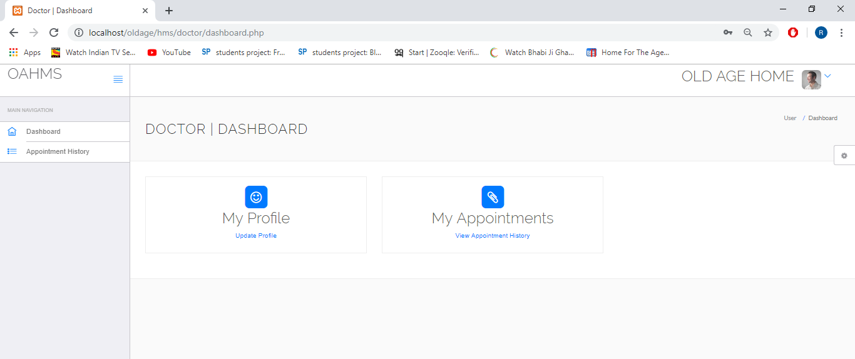

ADMIN DASHBOARD PAGE

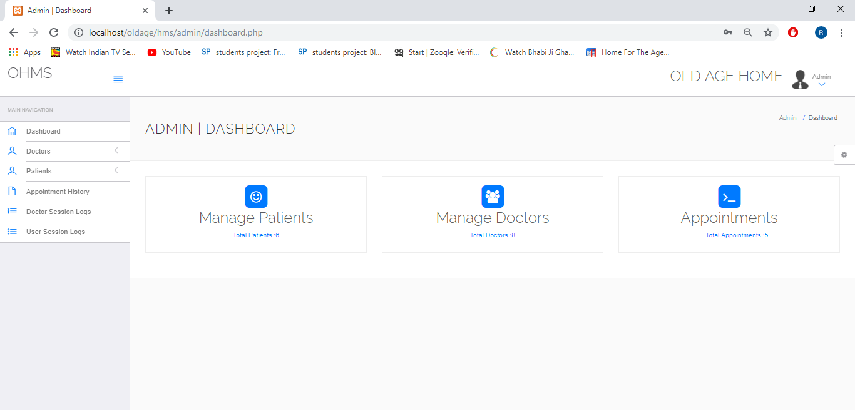

BOOK APPOINTMENT PAGE

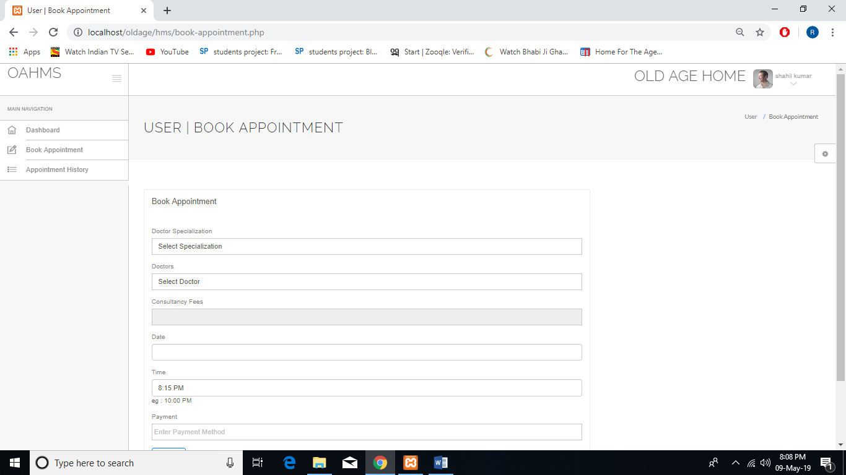

ADD DOCTOR PAGE

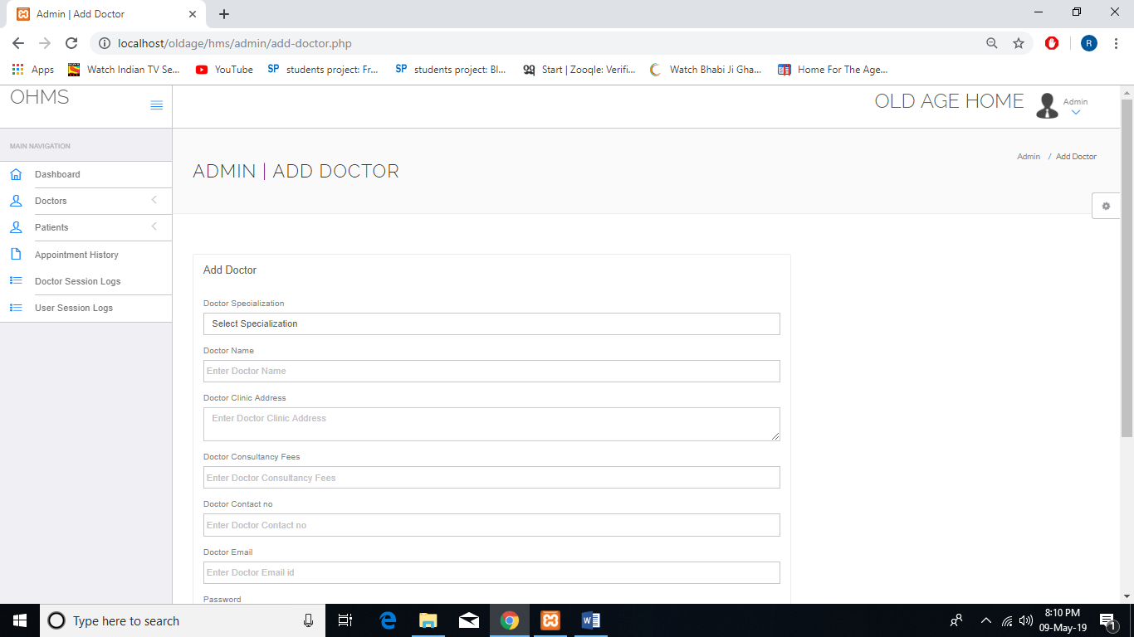

10. FUTURE ENHANCEMENT
Every minute that you spend reading this article, the average life expectancy in Britain will rise by 12 seconds. By the time you finish reading g2, your life expectancy will have gone up by six minutes. This time tomorrow, it will have increased by almost five hours. The reason is clear: rapid advances in medicine and biology have been one of the biggest achievements of the past century and we are all living longer. Where anyone reaching the age of 60 was considered to be near death's door at the turn of the 20th century, it is barely old enough for retirement at the turn of the 21st century

11. CONCLUSION
It is concluded that out of 378 respondents taken for the study, majority of the respondents belong to the age group between 60-65 years in both the districts. Regarding sex composition, majority of the respondents belong to male. On the basis of caste analysis, majority of the respondents belong to upper caste. Regarding educational level of the respondents, most of the respondents have studied upto primary or having lower literacy level, but number of respondents, who were highly educated, were large in number in district Rohtak as compared to Kurukshetra district. It has been noticed from out data that majority of the respondents in both the districts belong to Hindu religion. On the basis of type of family, it is obvious from the data that the majority of respondents in both the districts belong to nuclear family. But respondents, who belonged to joint family, are large in number in Kurukshetra as compared to respondents of Rohtak district. Analysis of marital status showed that majority of the respondents were married, while a considerable number of them were widow/widower. On the basis of monthly income analysis, it was found that the respondents, who belong to the lower income group, i.e. upto 8000/- were more in number in Kurukshetra district, while in higher income of above 8000/- the respondents of Rohtak district were large in number as compared to the respondents of Kurukshetra district. Regarding source of income, it was found that the majority of the respondents of both the districts, were depends on service pension or old age pension. When we threw a light on respondents’ past occupation, the majority of the respondents of Rohtak district, were engaged in government/private services, while in district Kurukshetra, majority of the respondents were engaged in agriculture and allied services in their past.

12. BIBLIOGRAPHY

- Websites

www.tutorialpoints.com
www.w3schools.com

www.phpeasystep.com

- Books

PHP Bible

PHP 5.

